Jonathan Reznik CIS50

Travel Website

Assignment 7

Introduction to Assignment

These were the tasks that I performed for the assignment,

1. Type content of the home and landing pages (one and two)
2. Find and insert images for each of the pages
3. Select an intended font/type for different text portions.

I ran into issues with the following:

1. Image sizing may need to change (not sure)
2. Issues with using Word as a environment (IDE) but these issues will work themselves out later…of course!
3. I also made comments in the file when seemingly appropriate such as format for placement of images in tables, etc.

(page 1 = Home Page for site)

As a premier Business Travel Site on the internet some of the people we are looking help include families and first time travelers all the way up to experienced travelers looking to make a successful trip to sites around the world, and providing assistance to your arrangements so you can be mostly concerned with just enjoying the trip and not worry about all this stuff once you are in another country.

I just hope that you enjoy the content of the site, which features items accessible to anyone not just paying customers. And in the end we hope you decide to plan your trip with jonsawesometraveldeals.com so that you can get more of the best from what we offer in travel planning.

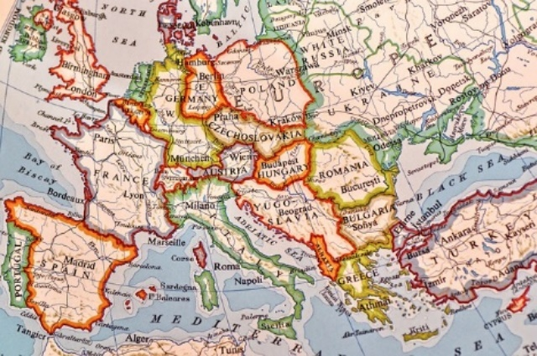

Figure 1 Source: <https://pixabay.com/en/map-europe-globe-countries-states-3483539/> Copyright: CC0 Creative Commons

|  |
| --- |
| Space reserved for further design of Navigation Bar and other navigational tools found on the site |

(Page 2 = Landing page for travel log links and itinerary)

Traveling

The content for this page is a conglomerate of the major elements that the site features also will include several tables, lists and other “elements” for users looking to visit the landing page and website. It is going to include a brief description of what purpose the site serves in terms of offering deals on travel, as well as travel arrangement planning, and various other travel related service like itinerary and travel tips.

This site is not about testimonials, so you won’t read long descriptions about the various experiences of clients or client testimonials but will instead see just enough to help you to decide which direction you may want to go in for your travels and to get you familiarized with some general concepts of traveling around the world.

If by the end of viewing the logs and reading the sample itinerary this seems like something you would like to proceed with then we look forward to helping you to assemble all the details from plane reservations/travel fare, to room arrangements/hotel reservations, and daily outing price quotes so that you will be able to do more exciting stuff on your travels without waiting to get started with planning it.

As always be sure to look at the top of the page for our social media, contact and other similar services.

Itinerary

Day 1 – Pack and leave for airport, arrive at destination and grab bit to eat

Day 2 – Relaxing morning, afternoon historical tour by bus/car

Day 3 – Day long city center site excursion, lunch, and evening show/event

Day 4 – Half-day excursion, afternoon in museum/art, dinner and night life

Day 5 – Full day outing to reach sites by car or train and time for dinner

Day 6 – Final day flexible plans

Day 7 – Wake and return to airport for return flight

Travel Log

Have a look at some of the travel logs to these destinations you may want to visit.

1. Berlin ***IMAGE LINK***
2. Italy (West Coast) ***IMAGE LINK***
3. Paris ***IMAGE LINK***
4. Denmark and Norway ***IMAGE LINK***

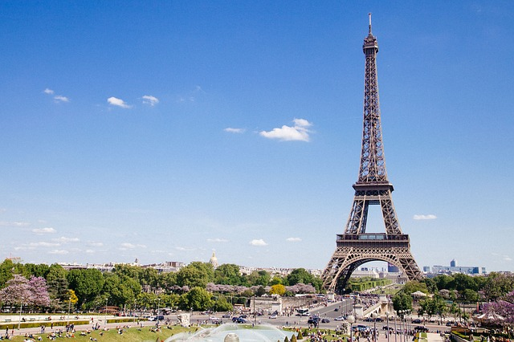

Figure 2 Source: <https://pixabay.com/en/eiffel-tower-paris-france-landmark-768501/> Copyright: CC0 Creative Commons

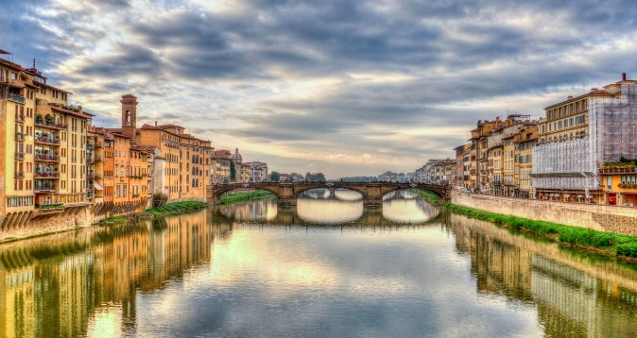

Figure 3 Source: <https://pixabay.com/en/arno-river-florence-firenze-italy-1066307/> License: CC0 Creative Commons

(Page 3 = Travel Tips)

Packing List

Daypack/Backpack

Comfortable Walking shoes

Water bottle and sunscreen for daytime excursions

Mostly casual wear and a bathing suit

Bring a camera

General Topics

How much money do you need when you travel?

* Food is likely to be more expensive while travelling so plan accordingly
* Cash for transportation costs ($100 for the week should be enough)
* Spending money for souvenirs and entertainment (personal preference here)

LINE BREAK

Finally follow these ***safety tips*** when traveling

1. Never carry your valuables with you wherever you go, always lock them up somewhere in the room before venturing off
2. Try to not leave your wallet exposed such as on a nightstand
3. Do not venture into unknown areas late at night, or without telling someone your plans
4. If you see something that doesn’t look right remember you are in a foreign country and the best thing is to wait and report it to someone who can relay the information to the authorities in that order

* Tips are provide as a reminder to experienced travelers and to first time travelers who have little experience.